TRAFFIC MANAGEMENT SYSTEM USING IOT

**PHASE 2: INNOVATION**

**PROJECT: TRAFFIC MANAGEMENT SYSTEM USING IOT**

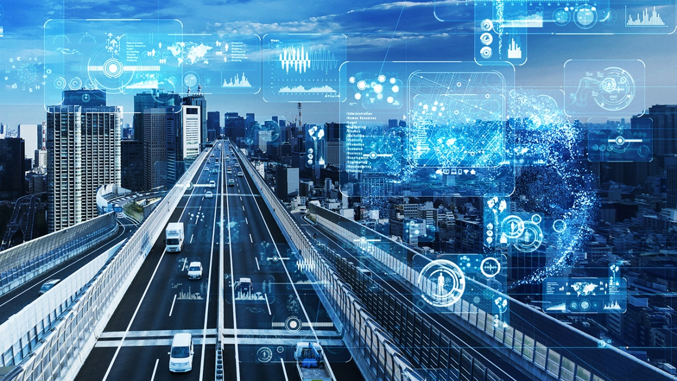

Introduction:

* Traffic congestion is a persistent issue in urban areas, leading to increased travel times, fuel consumption, and environmental pollution.
* Traditional traffic management systems often struggle to adapt dynamically to changing traffic patterns and demands.
* The integration of Internet of Things (IoT) technology offers a promising solution to enhance traffic management by enabling real-time monitoring, analysis, and intelligent control of traffic flow.

Objective:

* The primary objective of this project is to design and implement an IoT-based traffic management system that leverages advanced technologies to optimize traffic flow, reduce congestion, enhance safety, and improve overall transportation efficiency.
* By deploying a network of sensors and utilizing data analytics, this system aims to provide actionable insights to traffic operators and enable dynamic adjustments in traffic signal timings, ultimately leading to a smarter and more responsive traffic management.

Significance:

* Efficient Traffic Flow: Utilizing IoT, we aim to create an intelligent traffic management system that optimizes traffic flow by dynamically adapting traffic signals based on real-time data.
* Environmental Impact: By reducing traffic congestion and improving traffic efficiency, the system aims to decrease fuel consumption and greenhouse gas emissions, contributing to a greener environment.
* Safety Enhancement: Through real-time monitoring and incident detection, the system endeavors to enhance road safety by promptly responding to emergencies and minimizing potential accidents.
* Scalability and Adaptability: An IoT-based approach allows for scalable deployment and seamless integration of new sensors or technologies, ensuring the system can adapt to evolving urban landscapes and technological advancements.

System Architecture:

* Sensors and Data Acquisition Layer:
* *Traffic Flow Sensors:* Installed at strategic points to measure traffic density, vehicle speed, and direction.
* *Cameras:* Capture real-time images and videos for further analysis, including license plate recognition and incident detection.
* *Weather Sensors:* Gather data on weather conditions that may impact traffic.
* Data Processing and Edge Computing:
* *Microcontrollers and Edge Devices*: Receive data from sensors, process it locally, and filter relevant information before sending to the cloud.
* *Edge Analytics:* Perform initial data analysis and aggregation at the edge to reduce latency and bandwidth requirements.
* Communication Layer:
* *IoT Gateway:* Collects and aggregates data from edge devices and forwards it to the cloud for further processing.
* *Connectivity Protocols:* Utilize communication protocols (e.g., MQTT, HTTP, CoAP) to ensure seamless data transmission between edge devices, gateways, and the cloud.
* Cloud Infrastructure:
* *IoT Platform:* Manages device communication, data ingestion, storage, and provides APIs for data access.
* *Database:* Stores the collected and processed data for historical analysis and real-time decision-making.
* *Analytics Engine:* Utilizes machine learning algorithms and data analytics to process the data and extract actionable insights for traffic optimization.
* Traffic Management and Control:
* *Traffic Signal Control Algorithm:* An algorithm that processes the data from the analytics engine to dynamically adjust traffic signal timings for optimal traffic flow.
* *User Interface:* A web or mobile application that allows traffic operators to monitor traffic, view analytics, and manually control traffic signals if needed.
* Alerts and Notifications:
* *Notification Service:* Sends alerts to traffic operators or authorities in case of emergencies, accidents, or unusual traffic patterns.
* Security and Privacy:
* *Authentication and Authorization:* Ensure secure access to the system through proper authentication and authorization mechanisms.
* *Data Encryption:* Implement encryption protocols to secure data during transmission and storage.

Sensors and Data Collection:

* Traffic Flow Sensors:
* Inductive Loop Sensors: Embedded in roadways, detect changes in inductance caused by passing vehicles to measure traffic flow and vehicle speed.
* Infrared Sensors: Detect vehicle presence and count by emitting and sensing infrared light as vehicles pass by.
* Ultrasonic Sensors: Measure distance to detect vehicle presence and traffic density.
* Cameras:
* Video Cameras: Monitor traffic, record videos, and employ computer vision for vehicle detection, license plate recognition, and traffic analysis.
* Smart Cameras: Equipped with image processing capabilities to analyze traffic flow, detect congestion, and identify incidents.
* Weather Sensors:
* Anemometers: Measure wind speed and direction, critical for assessing how wind affects vehicle stability and traffic flow.
* Rain Sensors: Detect rainfall intensity, aiding in understanding its impact on traffic patterns and road conditions.
* Temperature and Humidity Sensors: Monitor environmental conditions affecting road safety and traffic behavior.
* Traffic Signal Sensors:
* Optical Sensors: Detect the presence of vehicles at traffic signals, assisting in optimizing signal timing based on traffic demand.
* GPS Devices:
* Vehicle GPS Trackers: Installed in vehicles to collect real-time location data, enabling traffic monitoring, route planning, and congestion analysis.
* Acoustic Sensors:
* Sound Sensors: Identify traffic noise patterns, honking, or accidents, contributing to traffic monitoring and incident detection.
* Pedestrian Sensors:
* Infrared or Ultrasonic Sensors:Detect pedestrian presence at crosswalks, enabling adjustments in traffic light timings for pedestrian safety.
* Mobile Apps and Crowdsourcing:
* Smartphone Sensors:Utilize smartphone sensors (GPS, accelerometer) through mobile apps to gather real-time traffic data from users, contributing to traffic monitoring and analysis.
* Radio Frequency Identification (RFID) Systems:
* RFID Readers: Identify and track vehicles using RFID tags, valuable for toll collection, vehicle identification, and traffic monitoring.
* License Plate Recognition (LPR) Systems:
* LPR Cameras:Capture images of license plates, enabling vehicle identification and monitoring.

IoT Platform in Traffic Management:

* Data Ingestion and Processing:
* Data Ingestion: Allows for efficient and secure ingestion of data from traffic sensors, cameras, and other devices.
* Data Pre-processing: Filters, cleans, and aggregates incoming data to prepare it for analysis and storage.
* Device Management:
* Device Registry: Maintains a registry of all connected devices, managing their metadata, configurations, and authentication.
* Security and Access Control: Implements security measures to ensure authorized access and secure communication between devices and the platform.
* Connectivity and Communication:
* Support for Protocols: Offers compatibility with various communication protocols (e.g., MQTT, CoAP , HTTP) to facilitate communication between devices and the platform.
* Bi-directional Communication: Allows devices to send data to the platform and receive commands or configurations in return.
* Data Storage and Management:
* Database: Stores collected data efficiently, allowing for retrieval, analysis, and historical data comparisons.
* Time-series Data Storage: Essential for storing and analyzing time-stamped traffic data, facilitating insights into traffic patterns and trends.
* Real-time Analytics:
* Analytics Engine: Provides real-time processing and analysis of traffic data, using algorithms to detect patterns, congestion, and anomalies.
* Rule Engine: Enables the definition of rules and triggers based on traffic conditions, allowing for immediate responses and alerts.
* Integration and APIs:
* API Endpoints: Offers APIs for easy integration with external applications, traffic management algorithms, and user interfaces.
* Integration with External Systems: Supports integration with third-party applications, traffic management software, and city infrastructure.
* Scalability and Flexibility:
* Scalable Infrastructure: Allows the platform to scale horizontally and vertically to handle growing amounts of traffic data and connected devices.
* Modular Architecture:Facilitates customization and expansion of functionalities to adapt to changing requirements.
* Dashboard and User Interface:
* Visualization Tools: Provides interactive dashboards and visualization tools for traffic operators to monitor traffic in real time.
* Alerts and Notifications: Sends alerts and notifications to traffic operators in case of traffic incidents or abnormal traffic patterns.

Algorithms for Traffic Pattern Analysis and Management:

1. K-means Clustering:

* Purpose: Group traffic data into clusters based on similarities (e.g., traffic density, vehicle speed) to identify traffic patterns in different areas.
* Application: Helps in understanding traffic patterns and congestion levels in different regions, aiding targeted traffic management strategies.

1. Density-based Spatial Clustering of Applications with Noise (DBSCAN):

* Purpose: Clusters traffic data points based on spatial density to identify congested areas and outliers.
* Application: Useful for detecting traffic congestion and abnormal traffic behavior, enabling timely interventions.

1. Kalman Filters:

* Purpose: Predicts future traffic states based on current and past traffic data, aiding in real-time traffic flow predictions.
* Application: Used for estimating traffic density, velocity, and acceleration to optimize traffic signal timings.

1. Shortest Path Algorithms (e.g., Dijkstra’s, A*):

* Purpose: Determines the shortest or quickest path between two points, assisting in route optimization for traffic diversions and emergency response.
* Application: Helps in suggesting the optimal routes for vehicles to reduce travel time and avoid congested areas.

1. Traffic Signal Optimization Algorithms:

* Purpose: Dynamically adjust traffic signal timings based on real-time traffic data to optimize traffic flow and reduce congestion.
* Application: Enhances traffic flow at intersections by minimizing waiting times and improving overall traffic efficiency.

1. Neural Networks (e.g., LSTM, CNN):

* Purpose: Utilizes deep learning to model and predict traffic patterns, congestion, and traffic flow based on historical and real-time traffic data.
* Application: Helps in forecasting traffic conditions, enabling proactive traffic management strategies.

1. Queue Length Estimation Algorithms:

* Purpose: Estimate the length of vehicle queues at traffic signals or congested areas to optimize signal timings and minimize congestion.
* Application: Enhances traffic light control by adjusting timings based on the length of queues to improve traffic flow.

1. Genetic Algorithms:

* Purpose: Optimize traffic signal timings by simulating natural selection to find the most efficient timing plan for traffic lights.
* Application: Aids in improving traffic flow and minimizing waiting times at intersections.

1. Reinforcement Learning (e.g., Q-Learning):

* Purpose: Allows traffic control systems to learn and adapt traffic signal timings based on trial-and-error learning from traffic feedback.
* Application: Enables the traffic management system to continually improve traffic signal control policies over time.

User Interface in Traffic Management IOT Project:

* Dashboard:
* Real-time Traffic Overview: Display current traffic conditions, congestion levels, and weather updates in a clear and visually appealing manner.
* Map View: Present an interactive map showing traffic flow, incidents, and signal statuses at different intersections.
* Traffic Analytics:
* Traffic Patterns: Visualize traffic patterns and historical data for informed decision-making.
* Congestion Heat maps: Highlight congested areas using color-coded heatmaps for quick identification.
* Traffic Signal Control:
* Manual Override: Allow traffic operators to manually control traffic signals if needed, with options to adjust timings and priority settings.
* Automated Optimization: Display automated traffic signal optimization options based on real-time traffic data.
* Alerts and Notifications:
* Real-time Alerts: Notify operators of traffic incidents, accidents, or unusual traffic behavior requiring immediate attention.
* Customizable Alerts: Allow customization of alert preferences based on severity and location.
* Traffic Event Log:
* Incident Reporting: Enable operators to log incidents, accidents, and road closures with details for future reference and analysis.
* Historical Event Viewer: Provide a log of past events for review and analysis.
* Route Planning:
* Optimal Route Suggestions: Assist operators in planning optimal routes for emergency response or traffic diversion based on real-time traffic data.
* Traffic-Enabled Navigation: Enable operators to view and choose routes considering traffic conditions.
* Weather Information:
* Current Weather: Display real-time weather information that could impact traffic, such as rain, snow, or strong winds.
* Weather Forecasts: Provide short-term and long-term weather forecasts to aid in proactive traffic management.
* User Management:
* Authentication and Authorization: Implement secure login mechanisms and role-based access control for different users (e.g., admin, traffic operators).
* Performance Metrics:
* Key Performance Indicators (KPIs): Showcase metrics like average traffic speed, traffic density, and overall traffic system efficiency.
* Historical Comparison: Allow comparison of current KPIs with historical data for trend analysis.
* Search and Filtering:
* Search Functionality: Allow operators to search for specific locations, incidents.

Program:

Code:

Import numpy as np

Import pandas as pd

From sklearn.preprocessing import MinMaxScaler

From tensorflow.keras.models import Sequential

From tensorflow.keras.layers import LSTM, Dense

# Load the dataset

Df = pd.read_csv(‘traffic_data.csv’)

Data = df[‘vehicle_count’].values.reshape(-1, 1)

# Normalize the data

Scaler = MinMaxScaler()

Data_normalized = scaler.fit_transform(data)

# Function to create sequences for LSTM

Def create_sequences(data, seq_length):

Sequences, labels = [], []

For I in range(len(data) – seq_length):

Seq = data[i:i+seq_length]

Label = data[i+seq_length:i+seq_length+1]

Sequences.append(seq)

Labels.append(label)

Return np.array(sequences), np.array(labels)

# Prepare the dataset with sequences

Sequence_length = 5 # You can adjust this based on your requirement

X, y = create_sequences(data_normalized, sequence_length)

# Split data into training and testing sets

Train_size = int(len(X) * 0.7)

X_train, X_test, y_train, y_test = X[:train_size], X[train_size:], y[:train_size], y[train_size:]

# Build the LSTM model

Model = Sequential()

Model.add(LSTM(units=100, activation=’relu’, input_shape=(sequence_length, 1)))

Model.add(Dense(units=1))

Model.compile(optimizer=’adam’, loss=’mean_squared_error’)

# Train the model

Model.fit(X_train, y_train, epochs=50, batch_size=32)

# Predict using the model

Predictions = model.predict(X_test)

Predictions = scaler.inverse_transform(predictions)

# Monitor traffic predictions

For i in range(len(predictions)):

Print(f”Predicted vehicle count at time {I + train_size + sequence_length}: {predictions[i][0]:.2f}”)